OLA BUSINESS INSIGHTS
MINIPROJECT REPORT- 2
Jessica Sriramula

The rise of ride-sharing platforms has transformed urban mobility, offering convenience and affordability to millions of users. OLA, a leading ride-hailing service, generates vast amounts of data related to ride bookings, driver availability, fare calculations, and customer preferences. However, deriving actionable insights from this data remains a challenge. To enhance operational efficiency, improve customer satisfaction, and optimize business strategies, this project focuses on analyzing OLA’s ride-sharing data. By leveraging data analytics, visualization techniques, and interactive applications, my goal in this project is to extract meaningful insights that can drive data-informed decisions.
To achieve this, I have been provided with the OLA excel file dataset, which I have cleaned to handle the null values and carrying out the necessary EDA steps to make sure that the data analysis becomes easier and more clear using VScode.
In VScode I have written my code using python and mysql with a duckdb connection to extract all the 10 data query outputs. After this, I have also created a streamlit application using the pyfile and ipynb file in VScode to display all the 10 queries of the ola business insights findings with graphical representation. For example: identifying peak demand hours and optimizing driver allocation, analyzing customer behavior for personalized marketing strategies, understanding pricing patterns and surge pricing effectiveness and detecting anomalies or fraudulent activities in ride data.
For my EDA steps, I have handled the null values in the ola dataset, checked for correlation of the columns if there is any linear relationship between any of the columns and also checked for outliers but have not deleted the outliers in the dataset because we don’t know if the outlier is entered by human error is a an actual true correct value entered. In a ride business, extreme numbers are often real business events, not system errors.

Here are three screenshots of my streamlit OLA business data analysis:
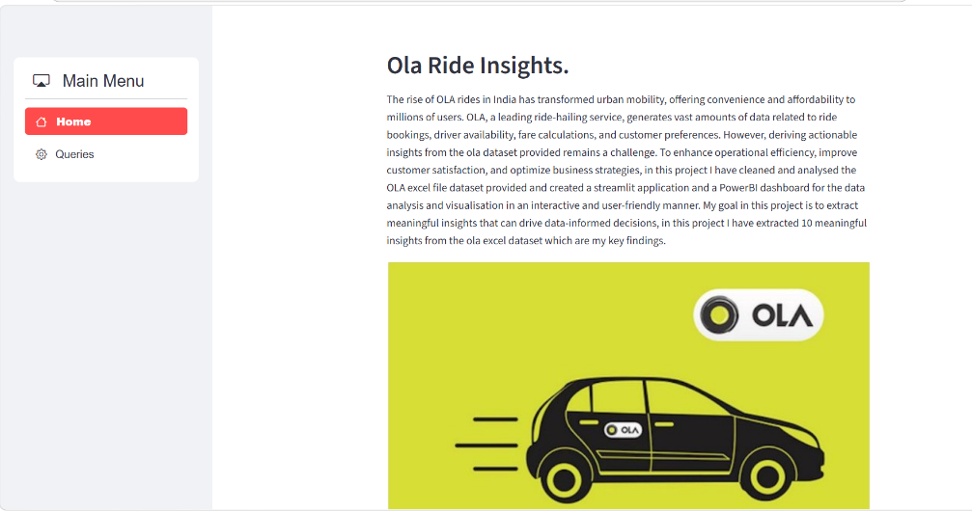

This is the home page of my streamlit application.

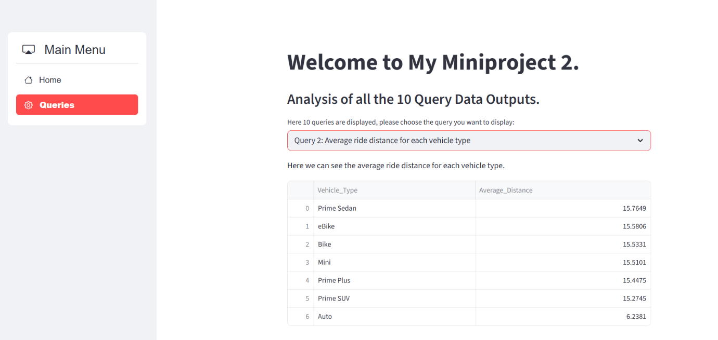
This is the queries page of my streamlit application where I have displayed the 10 query outputs of the data in a tabular form.

I have created a drop-down menu where we can choose the query we want to be displayed. A total of 10 queries are in this drop-down menu.

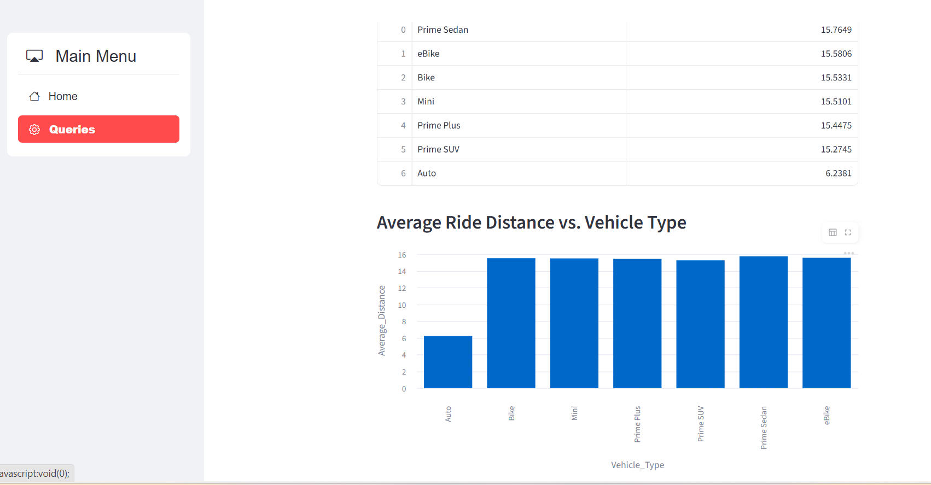

In the queries page, I have also created graphs to represent the 10 data outputs in a visual form for better analysis.

Here are the screenshots of my PowerBI dashboard:
(I have made a connection with VScode and my cleaned ola dataset in powerbi to make sure my dataset is the exact one I have used in VScode that has been cleaned after the EDA):
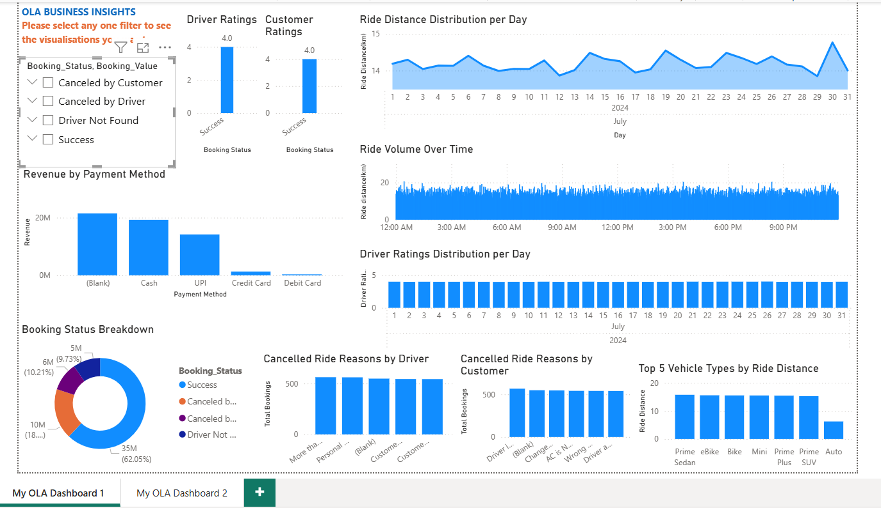
Here I have a created 10 visual graphs and visual analysis from the OLA cleaned dataset excel file in PowerBI. This can be used to see various insights and help drive business decisions for maximizing profit and customer satisfaction etc.

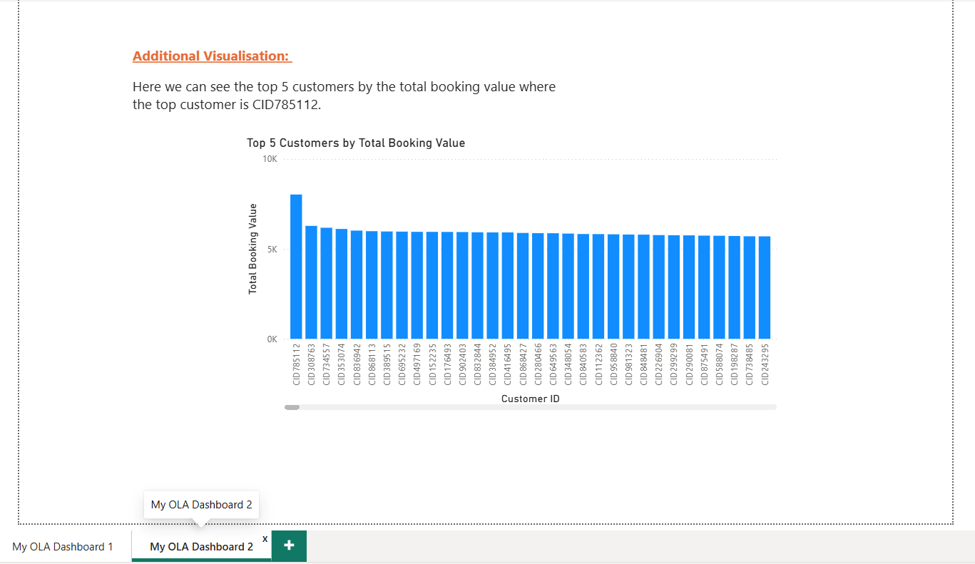

Here I have created another visualization in PowerBI which shows the top 5 customers from the ola booking service.

